**Stored Procedure as a Source**

**In SSMS create a stored procedure (sp):**

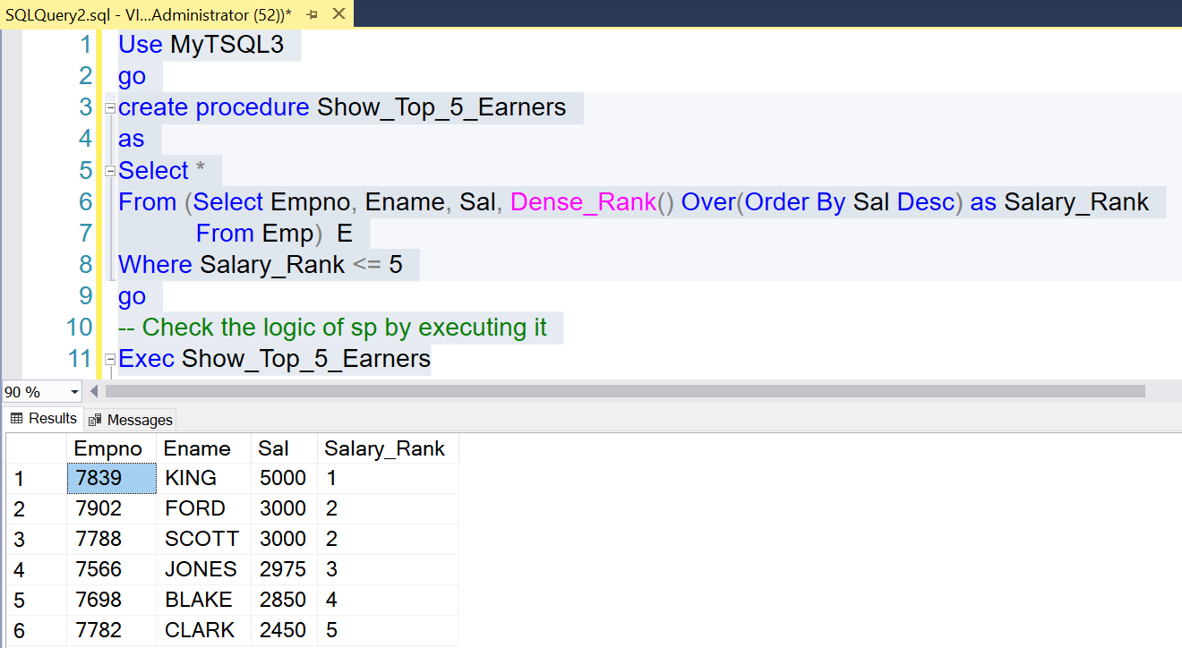

Use MyTSQL3

go

create procedure Show_Top_5_Earners

as

Select *

From (Select Empno, Ename, Sal,

Dense_Rank() Over(Order By Sal Desc) as Salary_Rank

From Emp) E

Where Salary_Rank <= 5

go

-- Check the logic of sp by executing it

Exec Show_Top_5_Earners

In PBI:

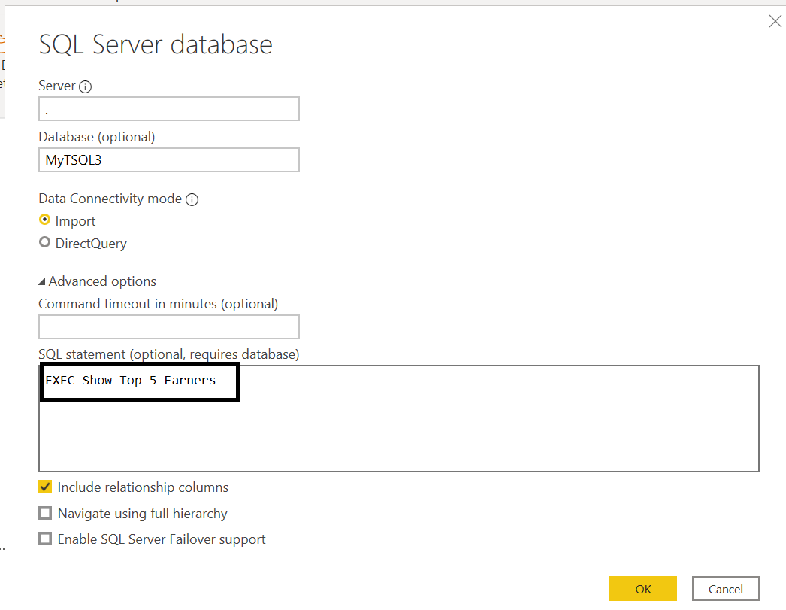

The table name will be Query<Number>